Refference youtube channel =>’ georgios magklaras’ video => ‘linux cgroup demonstration’

Some more practical approach about cgroups

Container also use cgroup for resource management

Essentially , a cgroup (control group) is a way to administer a number of resource and set resource limit to them by using certain resource controllers also knows as cgroup subsystem.

So you can administer CPU , memory , network bandwidth and block io (device driver) among a heirarchy of processes.

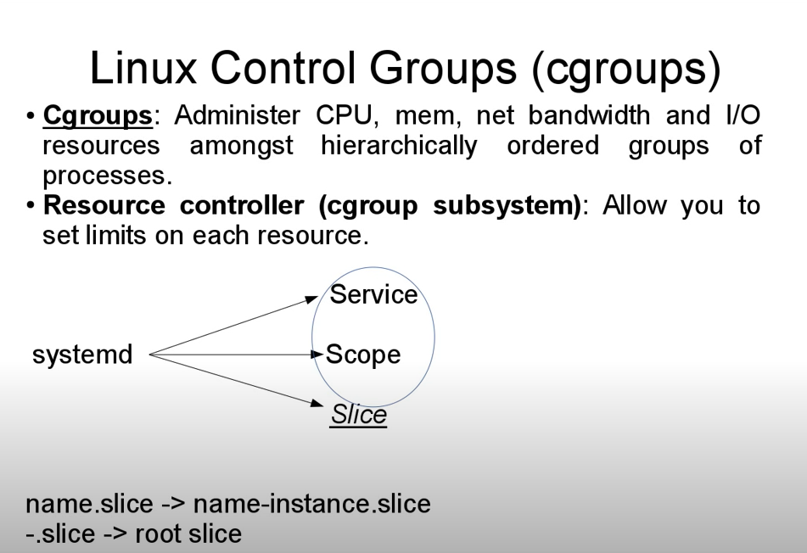

This defination is important use it , this picture is important

In the cgroup hierarchies we have first of all slice. Slice don’t actually contain any processes but they provide the blueprint for organizing a hierarchy around processes . in particular a slice might contain a service or a scope (as shown in picture) .

A services is hierarchcal group order set of process that actually reffer to the system services .

A Scope is little bit different is a hierarchy of process that can actually can start or create process dynamically. Transient session like user session , virtual machines or containers will be organized in a scope .

Slices are nemed in a way that they can hint hierarchy like (look at diagram)
Here in diagram we can see that a slice named ‘’name-instance.slice” should be child of a slice named “name.slice” .
And “-.slice “ is the root slice .

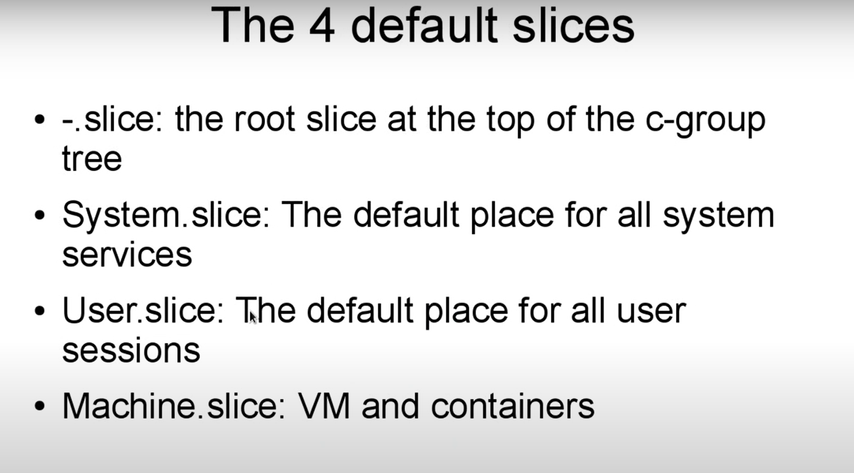

System.slice contain service like bluetooth , httpd , sshd daemon services .

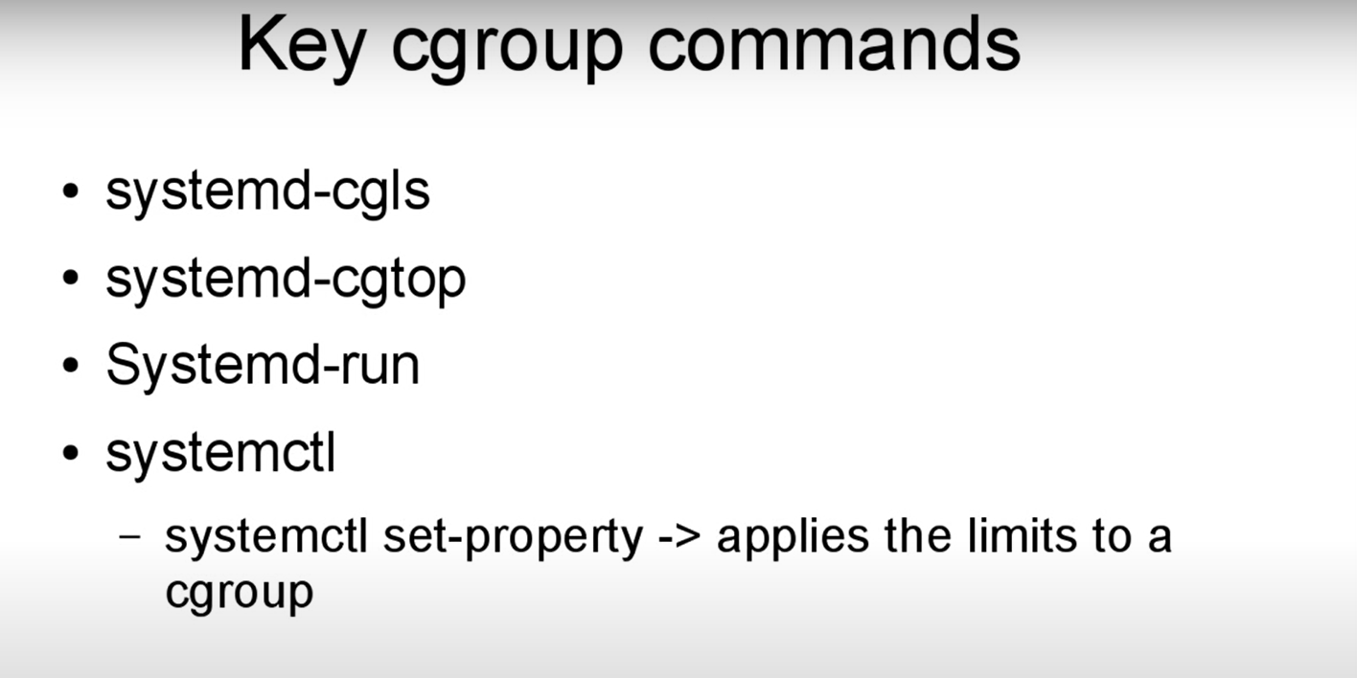

The above figure display most important cgroup commands

Systemd-cgls => will display the cgroup hierarchy of processes in particular.
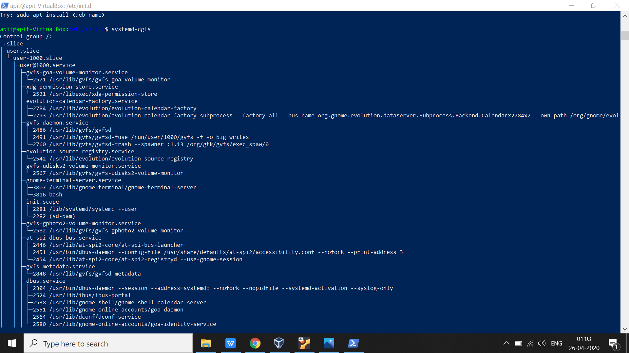

Here we can see , systemd-cgls will give us cgroup hierarchy of processes . which is started by the root slice “-.slice”

System-cgtop => is equivalent to TOP command but cgroup oriented .

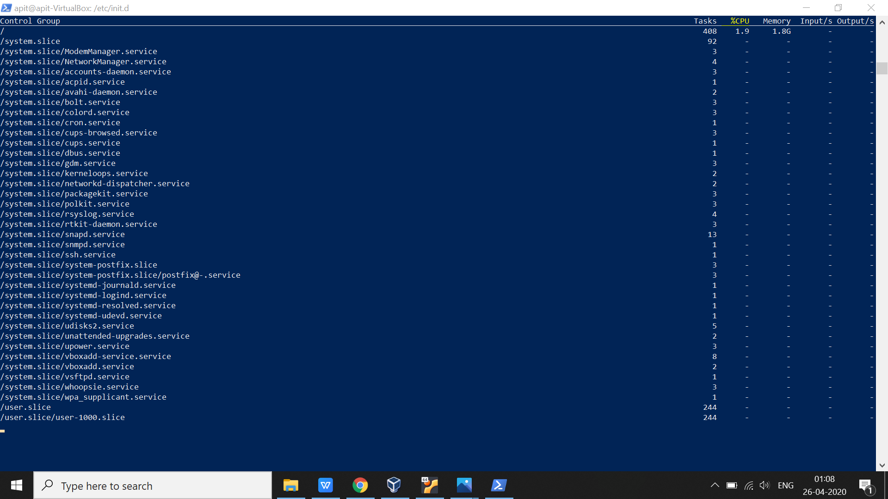

These are all the different slices with all the task , %CPU , memory , Input /second, output/second .

System-run => how we can start transit process and create scope .

Systemctl => used to apply limits to the cgroup like to limit cpu , memory , bandwidth and the number of other resources .

$ pstree => to see the process tree running on the system .

Ques => How to run a transient process with systemd ?

=> A transient is something which is not started by a permanent unit so to do that we have to invoke systemd
$systemd-run --unit=<unitname> --slice=<slice.name> [command]
For example => systemd-run --unit=arpitTop --slice=arpit.top top

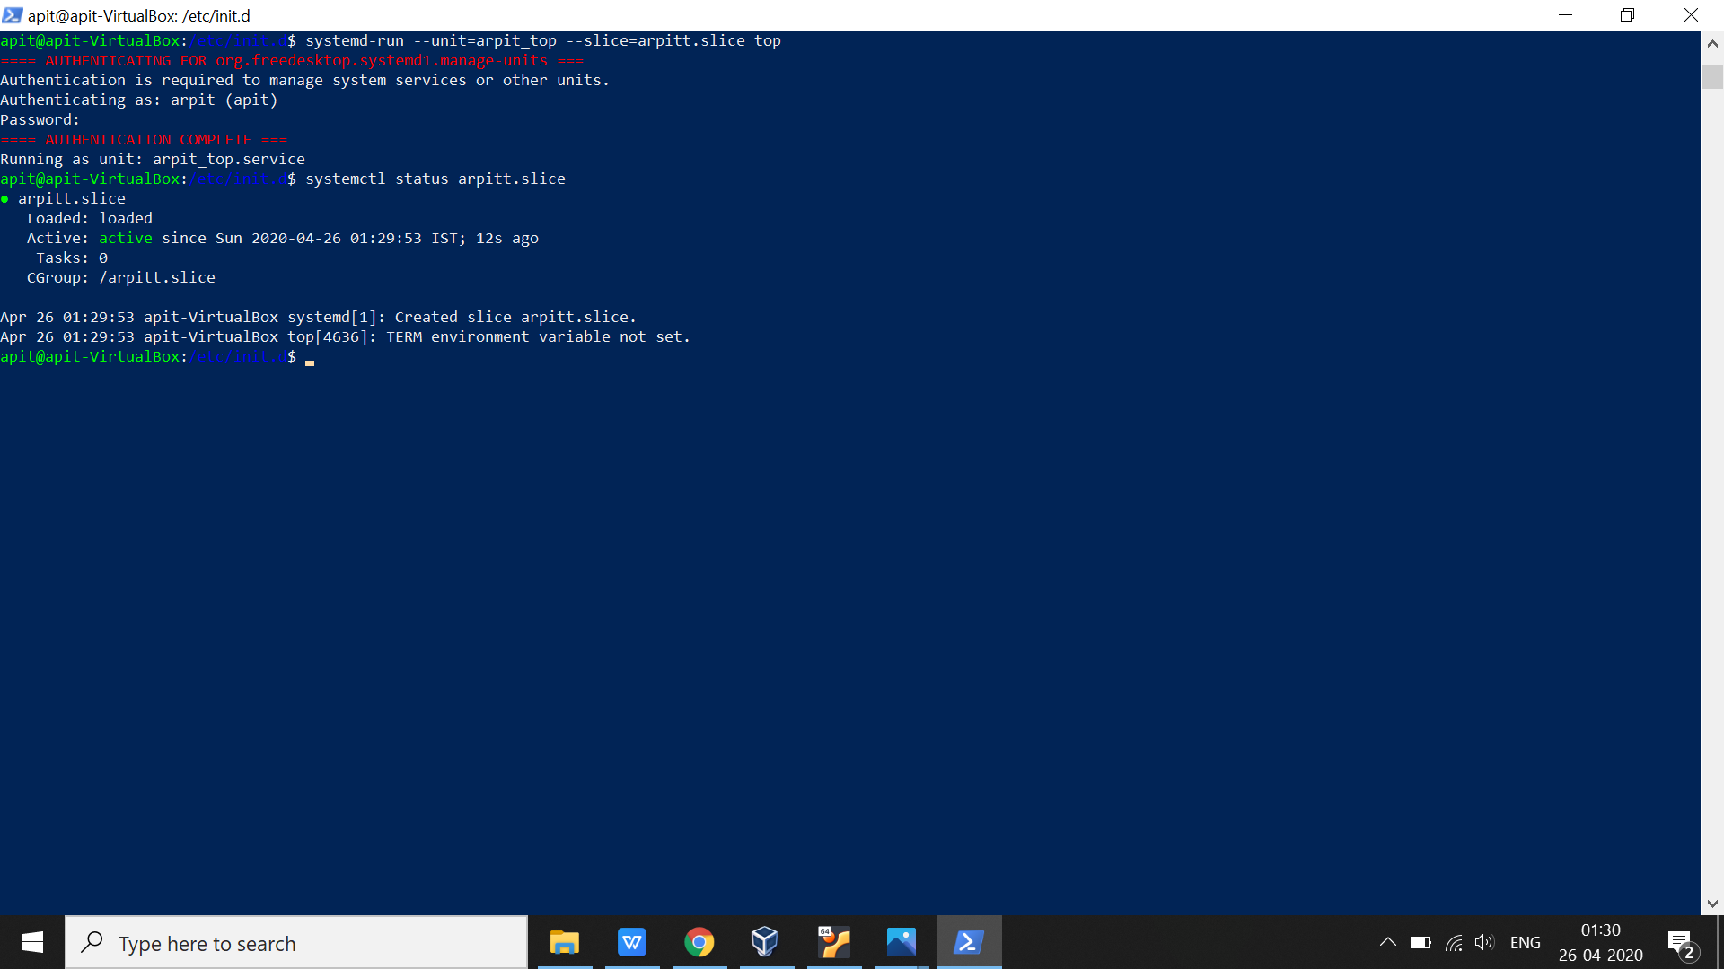

Remember :- This is transient process , so when you stop this (by systemctl stop arpitt.slice) , this will not be restart again as it get disappeared from the system .

Ques => how to actually make a proper unit file to start a proper service and apply resource limit to it ?

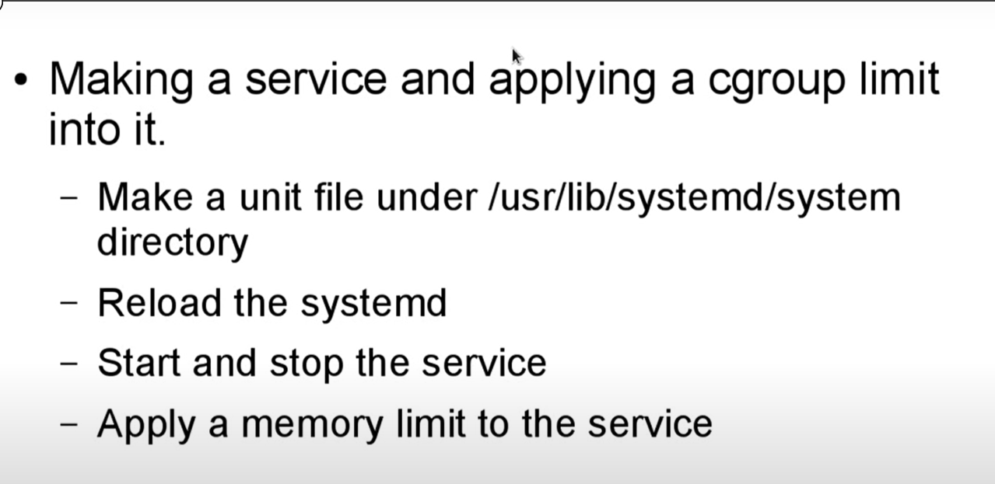

From here refference is youtube channel = ‘Nevyan Neykov ‘ title=Limit CPU usage on Ubuntu 19.10 with Systemd cgroups’

How to control resources over the processes w have in our system

Ubuntu has adopted systemd a way of controlling and creating services and it uses cgroups for this .

$ cd /sys/fs/cgroup => In this directory all the files are created dynamically this means we are starting service certain setting are created and after that they are disappear like having many directory as CPU , memory , bikio in so we can change lot os setting by typing information inside of those files .

The system uses slices in order to separate and control common resources ,
which means that for the user task we are using user slice for system .
For system task such as running services we are using system slice .
For virtual task such as running virtual machine we are using machine slice .

Now if we want to change user slice parameters then :-

$ cat /sys/fs/cgroup/cpu/user.slice/user-1000.slice => this is user slice common properties of all the users , in which this ‘1000’ signifies user id which we can obtain from ‘ cat /etc/passwd’

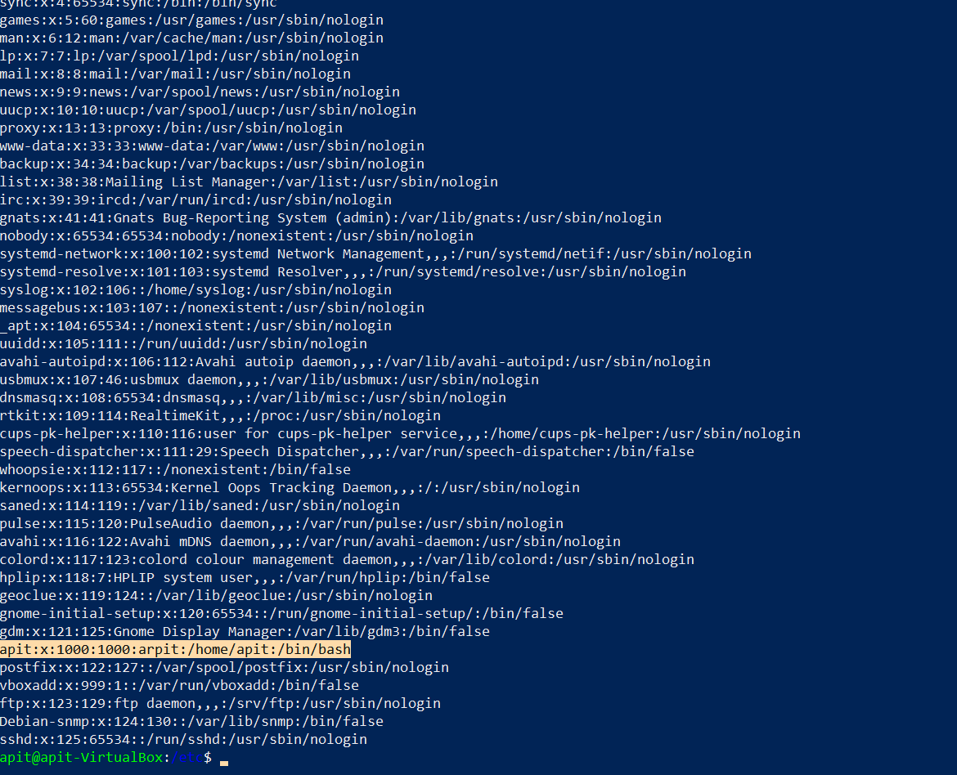

$cd /sys/fs/cgroup/cpu/user.slice/user-1000.slice/user@1000.service and here we can see many parameter which we can change for user slice

Like CPU quota :

To see CPU quota we have : $ cat cpu.cfs_quota_us
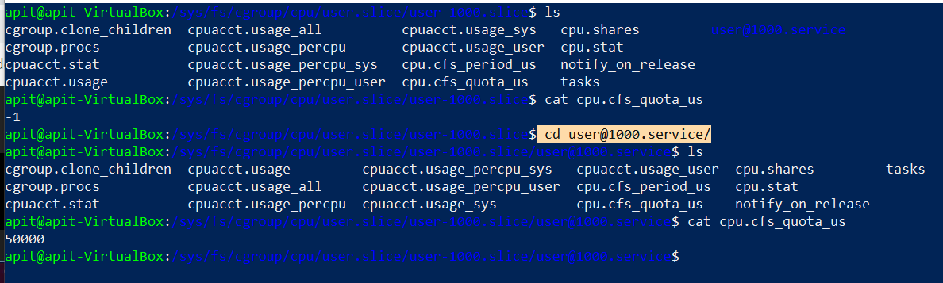

Here 50000 means that we use 50% of cpu

To change such properties we can use :

$ systemctl set-property user@1000.service CPUQuota=100%

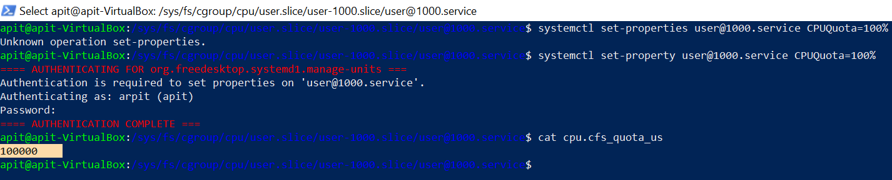

Now cpu quota is set to 100%

NOTE:-
To test the system that we have imposed we use stress command which is tool to impose load and stress test system .

$ stress --cpu 3 => by this command we can impose load of cpu quota by these 3 cpu stress process
$ top
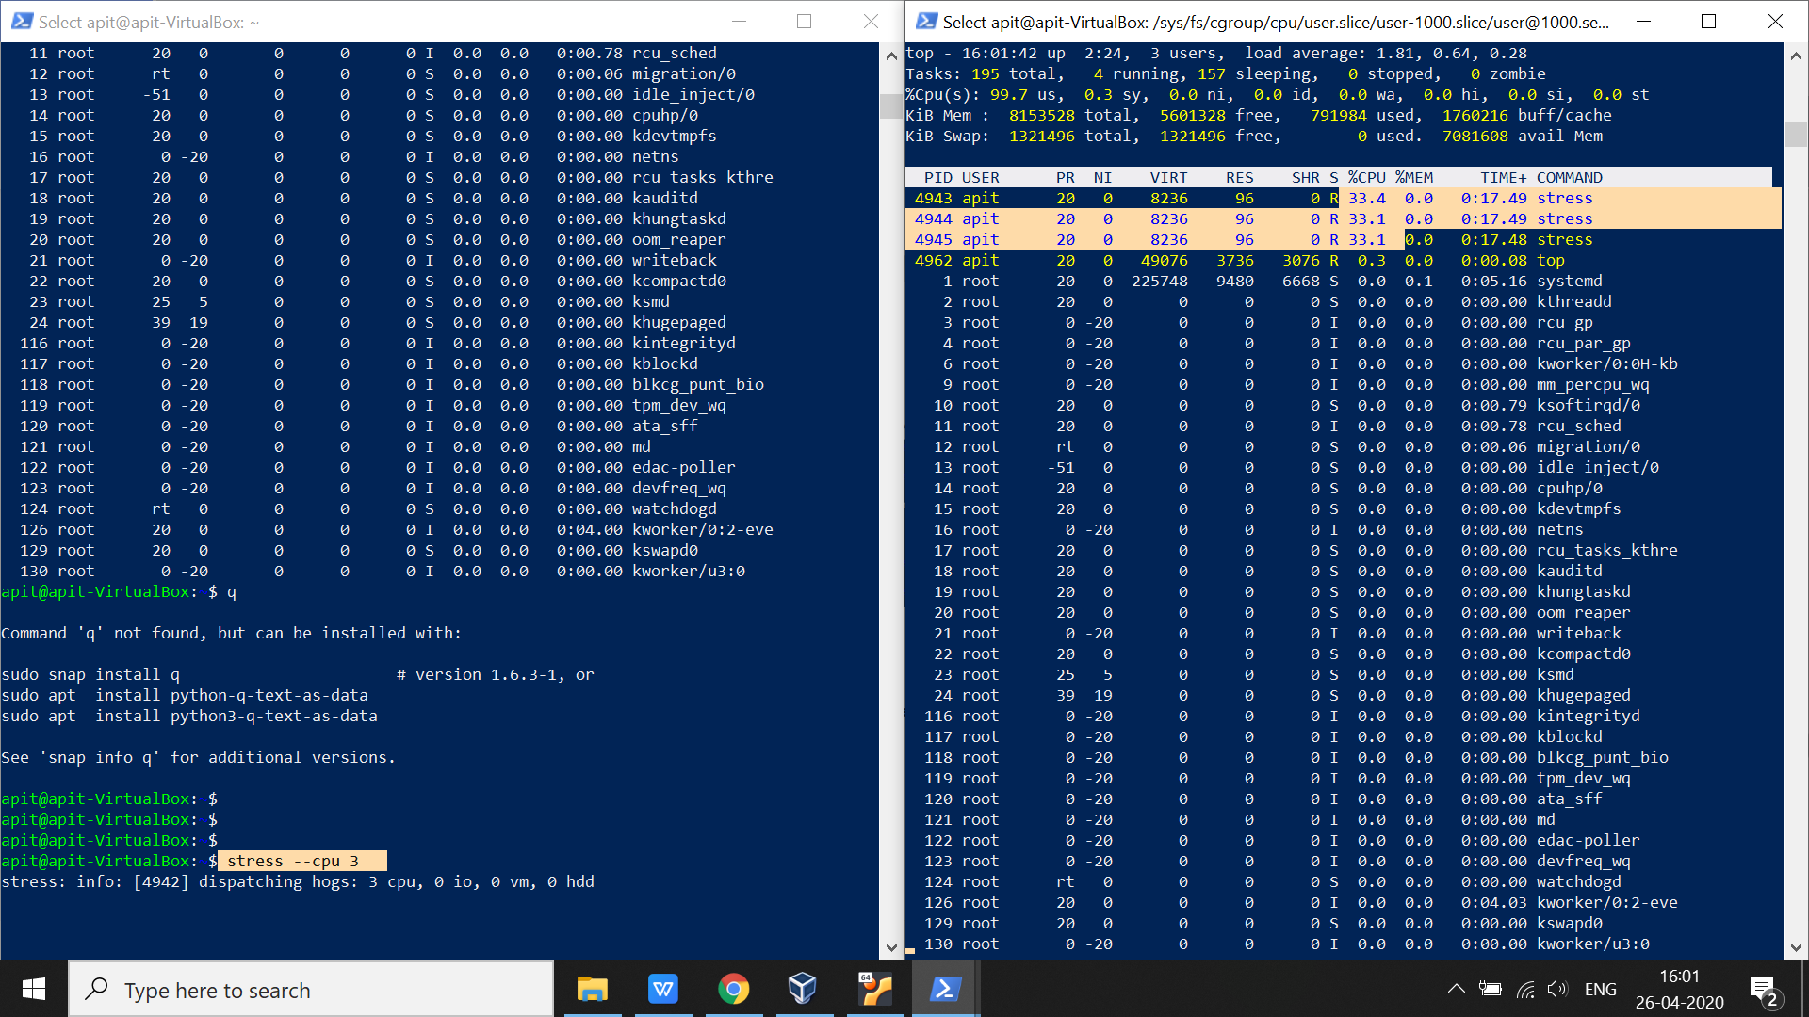

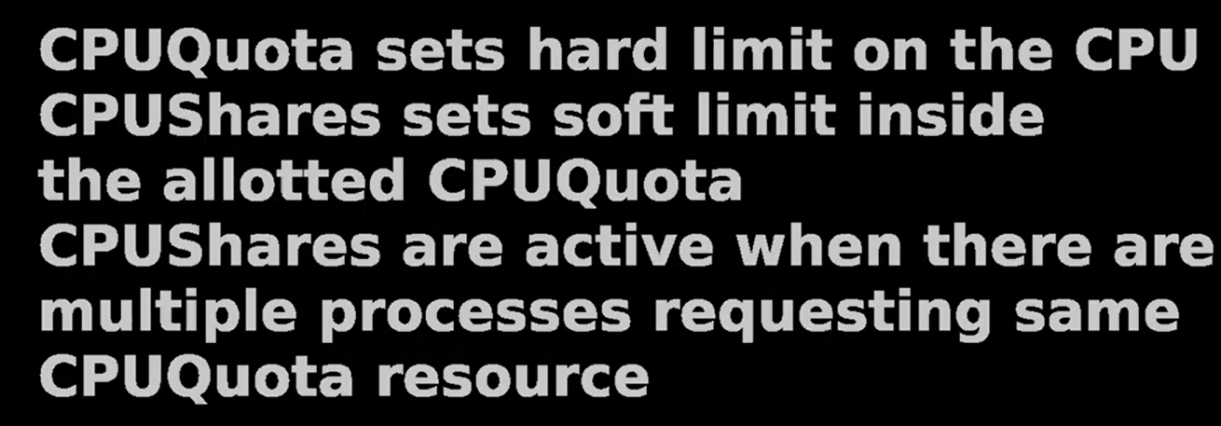

NOTE :- Maximum CPUShares is 1024 (which is 100%) if we want 25% of CPUShares we set value as 256 .

$ systemctl set-property user@1000.service CPUQuota=50% CPUShares=256

